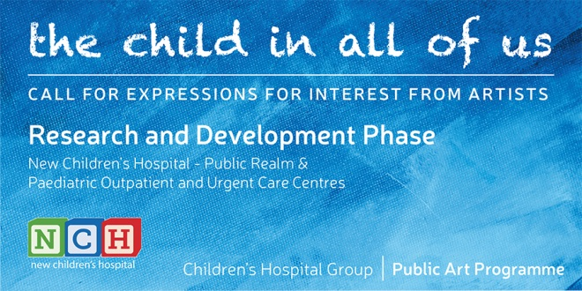
APPLICATION FORM
Contact details of artist
Name:

Address:

Daytime number: E-mail:
Commissions
Please tick which commissions are you interested in developing a proposal for. See briefing document for details.
 |  | Please tick
1 | The Frieze | ☐
2 | Welcome | ☐
3 | Orientation | ☐
4 | A Playful Wait | ☐
5 | Outpatient portals | ☐
6 | Welcome at car park | ☐
7 | Paediatric Outpatient and Urgent Care Centres | ☐

Statement
Please outline clearly in no more than 300 words the following:
(a) Your reasons for wanting to enter into this Research and Development phase leading to proposal(s) for artwork(s) for the new children’s hospital and / or its Paediatric Outpatient and Urgent Care Centres
(b) Your early thoughts on approaches to the development of proposals

Contact details of referees

First referee

Name of first referee:

Address:

Daytime number: E-mail:

Second referee

Name of first referee:

Address:

Daytime number: E-mail

Attachments
Please attach:
- A two-page current CV which clearly identifies the artist’s experience of making work as part of an art commissioning process
- Documentation of past work in the form of 5 to 10 good quality images. All images should be captioned with title, materials, scale and name of commissioning body, if relevant. Please do not send website links in lieu of images.

All the above including the application form should be compiled into one PDF document to be clearly marked with the artist’s name and contact details.

