 cid:image013.jpg@01D5948F.0207D6C0 cid:image014.jpg@01D5948F.0207D6C0

**BAM COMMUNITY BENEFIT FUND FOR THE NEW CHILDREN’S HOSPITAL**

Community

Grants Scheme

2020

Closing Date: 31/3/2020

 cid:image013.jpg@01D5948F.0207D6C0 cid:image014.jpg@01D5948F.0207D6C0

**BAM COMMUNITY BENEFIT FUND FOR THE NEW CHILDREN’S HOSPITAL**

**COMMUNITY GRANTS SCHEME**

**Introduction**

BAM, in association with the Community Benefits Oversight Programme for the new children’s hospital[1], has established a Community Grants Scheme. The aim of the Grant Scheme is to support and encourage a diverse range of community based initiatives that will improve the quality of life for local communities around the new children’s hospital. We want to encourage groups with good ideas about what will make their communities better places to live. Your organisation needs to be a not-for-profit voluntary organisation, community group or a registered charity. Consideration will be given to applicants that can demonstrate the benefits of a new, innovative or expanded project for the local community and residents.

The fund will assist community-based projects that:

* Are well founded and supported by their community
* Are based on an acknowledgement of, and/or provision for, social inclusion and promotion of equality
* Are available without discrimination to all members of the community that the project serves.
* Can demonstrate project ambition and ability to deliver the project

The Community Benefit Grant Scheme will exist for a period of 3 years with annual calls for applications in 2020, 2021, and 2022. The allocation for 2020 is €50,000 and will be divided into grant bands of €500-€1,000, €1,000 to €5,000 and €5,000 to €10,000. Please note that only very few applications will be supported at the higher band.

The Grant Scheme is managed by the Community Benefit Fund (CBF) Committee which is comprised of the Independent Chairperson of the Community Benefit Oversight Group and senior representatives of BAM, Children’s Health Ireland and the National Paediatric Hospital Development Board. An independent assessor with relevant expertise will be appointed to assist with shortlisting and recommending projects for approval.

## **Key Themes:**

The following themes have been identified in keeping with the Community Benefit Programme for the new children’s hospital:

* **Building Stronger Communities** – activities that strengthen community development and cohesion, social inclusion and integration
* **Greener Communities** - environmental enhancement and sustainability
* **Recreation, Sports, Arts and Culture**
* **Education & Skills –**  initiatives that support educational and employment opportunities

Activities must benefit the local community and relate to at least one key priority. Applications are particularly welcome that seek to enhance the lives of children and young people or promote cross-generational activities and, while we encourage initiatives which improve the lives of as many residents as possible in the broadest and most inclusive sense, we also have an emphasis on projects which focus on those in the community who are most disadvantaged.

## **General Criteria**

1. Projects may be considered if they demonstrate that they will have a positive effect on community services, facilities, services, amenities or physical appearance of the local area.
2. Funds will be allocated on the basis of genuine need, where the project is considered to be viable and sustainable in the long-term and where there is adequate public access and community support.
3. Financial assistance will not be provided retrospectively, and expenditure incurred before an offer of support is made will be ineligible. However, where a group can demonstrate to the satisfaction of the CBF Committee that expenditure was necessarily incurred on a significant project due to requirements to avail of other grants, the CBF Committee at its absolute discretion may decide to grant aid to such a project that has commenced.
4. Funding may be allocated to eligible projects in co-ordination with other funding streams to create added value and this must be clearly outlined in the application.
5. The level of grant payable may be determined having regard to the amount of other funds generated/raised by the applicant.

**Community Benefit Area**

The geographic area identified for the Grant Scheme consists of Dublin 8 and certain parts of Dublin 12, in alignment with the hospital catchment area as in the EY study, “Harnessing the Potential”.

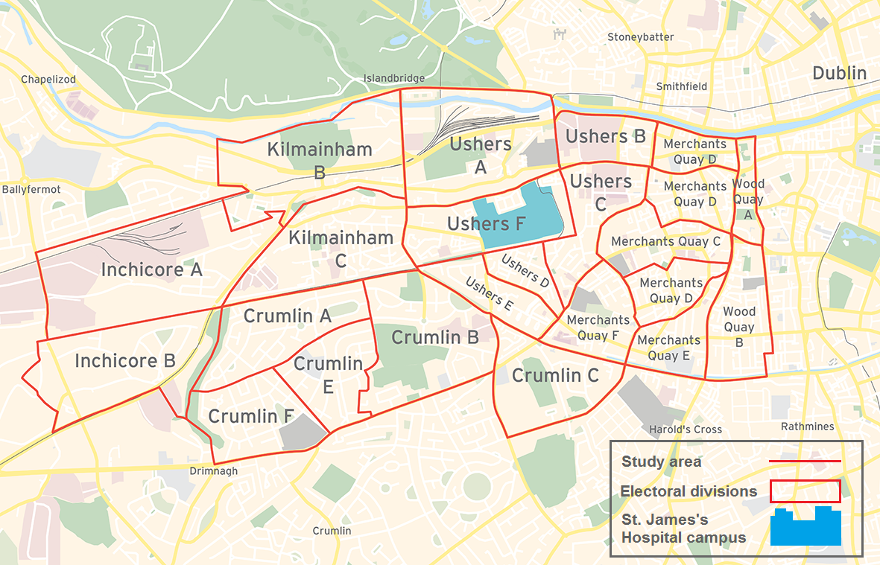

## **Eligibility**

The Community Grants Scheme will provide financial assistance to community-based clubs/groups, voluntary and not for profit organisations, for the development of projects in the locality (as defined above under Community Benefit Area).

In general, applications will be considered from not for profit organisations or associations which:

* Are registered and in good standing with their national representative bodies (if any)
* Have a constitution or rules acceptable to the CBF Committee
* Hold annual general meetings
* Have audited financial and other records available to the CBF Committee, if required
* May not be part of a formal structure as described above but who can demonstrate that they are representative of their local community.
* The fund **will not** cover promotion of religious or political causes

**Assessment of applications**

An independent assessor will be appointed to review all applications, shortlist and make recommendations for successful projects on the basis of:

* The extent to which proposed activities will benefit intended target group or area
* The use of innovative or imaginative approaches
* Cross community and partnership strategies
* The capacity of applicants to carry out the proposed project
* Overall quality and value for money
* Long term viability and sustainability

The Community Benefit Fund Committee reserve all rights to modify at any time and/or to terminate this bursary scheme and/or to make whatever decisions in regard to the operation of this bursary scheme that may be required and their determination(s) on all these matters shall be final and there shall be no right of appeal.

 cid:image013.jpg@01D5948F.0207D6C0 cid:image014.jpg@01D5948F.0207D6C0

**BAM COMMUNITY BENEFIT FUND FOR THE NEW CHILDREN’S HOSPITAL**

**COMMUNITY GRANTS SCHEME APPLICATION FORM 2020**

**NOTE: Closing Date 31st March 2020**

**For office use only:**

Reference Number:

Date Received:

**GROUP /ORGANISATION NAME:**

**ALL APPLICATIONS ARE TO BE RETURNED TO:**

**BAM COMMUNITY BENEFIT FUND COMMITTEE,**

**c/o National Paediatric Hospital Development Board**

**Block A, Herberton, St James’s Walk,**

**Rialto, Dublin 8**

**OR EMAILED TO CommunityGrants@nph.ie**

**By 5pm Tuesday 31st March 2020**

**CLOSING DATE WILL BE STRICTLY ADHERED TO.**

***Please note that additional information in support of your application can be included.***

***Please read the Terms and Conditions on page 6/7. Please sign DECLARATION on page 12.***

**BAM Community Benefit Fund for the new children’s hospital**

**Community Grants Scheme**

BAM, in association with the Community Benefits Oversight Programme for the new children’s hospital[2], has established a Community Grants Scheme. The aim of BAM’s Community Benefit Grant Scheme is to support and encourage a diverse range of community based initiatives that will improve the quality of life for local communities around the new children’s hospital. Under the scheme community, voluntary and not-for-profit organisations and/or groups may apply for grants for activities which benefit the local community. Applications must relate to at least one key priority area in order to be eligible for consideration.

**Key Priority Areas**

* **Building Stronger Communities** – activities that strengthen community development and cohesion, social inclusion and integration
* **Greener Communities** - environmental enhancement and sustainability
* **Recreation, Sports, Arts and Culture**
* **Education & Skills –**  initiatives that support educational and employment opportunities

***TERMS AND CONDITIONS***

* The Community Grants Scheme will support community activities promoted by community and voluntary groups subject to available resources.
* Activity must benefit the local community and relate to at least one key priority.
* The Community Benefit Fund Committee, with the assistance of an Independent Assessor, will assess applications taking into consideration it’s available financial resources and reserves the right to award grants on this basis.
* The information supplied by the applicant group /organisation must be accurate and complete.
* Misinformation may lead to disqualification and/or the repayment of any grant made.
* All information provided in respect of the application for a grant will be held electronically and may be made available to third parties involved in the management and administration of this grants scheme. The Community Benefit Fund Committee reserve the right to publish a list of all grants awarded including the name of the group/organisation receiving funding, the general location of the group and the general purpose of the grant.
* Information provided in respect of the application for a grant will only be used for the purpose of administering the Community Grants Scheme 2020.
* The Community Benefit Fund Committee in evaluating applications under the Community Grants Scheme may seek advice and consult with other agencies and may disclose information on projects under consideration to those experts and agencies.
* The Freedom of Information Act 2014 applies to all the records held by the National Paediatric Hospital Development Board (NPHDB) which in involved in the oversight of this grants scheme. Under the Freedom of Information Act 2014, details contained in applications and supporting documents may, on request, be released to third parties. If there is information contained in your application which is sensitive or confidential in nature, please identify it and provide an explanation as to why it should not be disclosed. If a request to release sensitive information under the legislation is received, you will be consulted before a decision on whether or not to release the information is made. In the absence of the identification of particular information as sensitive, it could be disclosed without any consultation with you
* It is the responsibility of each organisation to ensure that it has proper procedures and policies in place including appropriate insurance to support the proposed activity..
* Where relevant, applicants must provide evidence of a Child Safeguarding Statement and meet all the requirements of the Children First Act 2015 which includes Garda vetting for all officers and those associated with the project.
* Only completed, signed applications submitted by **5.30 pm on Tuesday 31st March 2020** on the official Community Grants Scheme 2020 application form will be considered.
* Successful applicants must submit a progress report on the project funded if requested by the Community Benefit Fund Committee.
* Evidence of expenditure, receipts /invoices must be retained and provided to the Community Benefit Fund Committee if requested.
* BAMs contribution and the Community Benefit Programme for the new children’s hospital must be publicly acknowledged in all materials associated with the purpose of the grant.
* Generally no third party or intermediary applications will be considered.
* Late applications will not be considered.
* Applications will be accepted by email and should be sent to **CommunityGrants@nph.ie**
* Applications by post should use the correct value of postage stamps and allow sufficient time to ensure delivery not later than the closing date of **5.30 pm Tuesday 31st March 2020.**
* Claims that any application form has been lost or delayed in the post will not be considered, unless applicants have a Post Office Certificate of Posting in support of such claims.
* Breaches of the terms and conditions of the grants scheme may result in sanctions including disbarment from future grant applications.
* Some grants awarded may be conditional on a further agreement between the Community Benefit Fund Committee and the proposed grantee on the application of the grant.
* Applicants are required to have a bank account in the official name of the organisation/group as no payments can be made to Third party or personal accounts. Bank, Post Office or Credit Union accounts are acceptable.
* PRIVACY (General Data Protection Regulation G.D.P.R.).  
  The purpose for processing your data is to process your application for the BAM Community Grant Scheme 2020. The information you provide will be assessed by the Community Benefit Fund Committee with the assistance of an Independent Assessor who will check applications meet the grant scheme criteria, terms and conditions and governance requirements. Your information will be retained for five years. If you do not furnish the personal data requested, we will not be able to process your application.

You have the following rights, in certain circumstances and subject to applicable exemptions, in relation to your personal data:

* the right to access the personal data that we hold about you, together with other information about our processing of that personal data
* the right to require us to rectify any inaccuracies in your personal data
* the right to require us to erase your personal data
* the right to request that we no longer process your personal data for particular purposes
* the right to object to our use of your personal data or the way in which we process it

Please note that to help protect your privacy we take steps to verify your identity before granting access to personal data.

If you would like to exercise any of these rights, please submit a request to our Data Protection Officer outlining the specific details of the request: Email: [dataprotection@nph.ie](mailto:dataprotection@nph.ie) . All valid requests will be processed without undue delay and in any event within one month of receipt of the request. This period may be extended by up to two further months where necessary.

**All questions on this form must be answered. Please write your answers clearly in block letters.**

**SECTION 1 – CONTACT DETAILS**

|  |  |
| --- | --- |
| **Name of Group / Organisation** |  |
| **Address** |  |
| **Contact Name** |  |
| **Role in Group / Organisation** |  |
| **Telephone Number** |  |
| **E-mail** |  |
| **Website** |  |

**Please delete YES or NO as appropriate to the following questions.**

**Have you received funding under any other grants scheme within the last three years? YES / NO**

**If YES please give details:-**

|  |  |
| --- | --- |
| **Name of grants scheme / organisation you applied to** |  |
| **Funding Scheme, amounts involved.** |  |

**PLEASE NOTE THAT APPLICANTS ARE REQUIRED TO HAVE A BANK ACCOUNT IN THE OFFICIAL NAME OF THE ORGANISATION/ GROUP AS NO PAYMENTS CAN BE MADE TO A THIRD PARTY OR PERSONAL ACCOUNT.**

**SECTION 2 - GROUP/ ORGANISATION DETAILS**

**Purpose of group / organisation?**

**______________________________________________________________________________________**

**_______________________________________________________________________________________**

**Year established: _______________________________________________________________________**

**Please provide a brief organisational description of your group / organisation**

**e.g. committee structure, meeting schedule etc.**

**_______________________________________________________________________________________**

_______________________________________________________________________________________

**_______________________________________________________________________________________**

**Has your Organisation / Group registered with the Dublin City Public Participation Network (PPN)?**

**YES / NO**

**Is your organisation affiliated or connected to any relevant local regional or national body? YES/NO**

**If Yes please give details below.**

**Name of Organisation(s):**

**_______________________________________________________________________________________**

**Do you or have you in the past received funding from any other organisation? YES / NO**

**If YES please give details of main funders below.**

|  |  |
| --- | --- |
| **Name of Organisation(s):** |  |
| **Amount Received:** |  |
| **Date Received:** |  |

**Charitable Status Number (if applicable): ___________________________________________________**

**SECTION 3 - PURPOSE OF GRANT**

## Please tick which key priority area/s this grant application relates to:

* **Building Stronger Communities**
* **Greener Communities**
* **Recreation, Sports, Arts and Culture**
* **Education & Skills**

## **What is the purpose of the grant? (Outline details of the activity).**

____________________________________________________________________________

____________________________________________________________________________________

____________________________________________________________________________________

____________________________________________________________________________________

___________________________________________________________________________________

____________________________________________________________________________________

**Who is the target group that will benefit from this activity? Please give approximate numbers.**

**____________________________________________________________________________________**

## **Where will this activity take place? (Please indicate if activity is at Dublin 8 or Dublin 12)**

____________________________________________________________­­­­­­­­­_________________

____________________________________________________________­­­­­­­­­_________________

**Start Date of activity__________________**  **End Date of activity__________________**

____________________________________________________________­­­­­­­­­_________________

____________________________________________________________­­­­­­­­­_________________

**Child Safeguarding Statement**

**Do you have a Child Safeguarding Statement in Place? YES / NO**

**SECTION 4 – FUNDING**

**Please tick which Band your application falls under:**

€500.00- €1,000.00  €1,000.00-€5,000  Over €5,000 ***(limit is €10,000)***

**Please give the exact amount being applied for under the BAM Community Grants Scheme?**

**€ _______________**

|  |  |
| --- | --- |
| **What is the overall total cost of this activity?**  **What % of costs will be covered by the grant if this application successful?** | **€**  % |

**Please provide a detailed breakdown of the costs of the activity**

|  |  |
| --- | --- |
| **Item** | **Cost** |
|  |  |
|  |  |
|  |  |
|  |  |
|  |  |

**Where will you source any shortfall of funding?**

|  |  |
| --- | --- |
| **Source** | **Amount** |
|  |  |
|  |  |
|  |  |
|  |  |
|  |  |

**SECTION 5**

***DECLARATION***

**Position held in organisation: ________________________________**

**I declare that the information given in this form is correct.**

**I confirm I have read and fully understand the Terms and Conditions of the BAM Community Grants Scheme (See page 2 and 3 of application form).**

**I confirm that this grant application is submitted in acceptance and compliance with the Terms and Conditions.**

**NAME IN BLOCK CAPITALS SIGNATURE**

|  |  |
| --- | --- |
|  |  |
| **Position held in group / organisation:** |  |
| **Date:** |  |

1. For further information please see <https://www.newchildrenshospital.ie/community-benefit/>
2. For further information please see <https://www.newchildrenshospital.ie/community-benefit/>