 cid:image013.jpg@01D5948F.0207D6C0 cid:image014.jpg@01D5948F.0207D6C0

**BAM COMMUNITY BENEFIT FUND FOR THE NEW CHILDREN’S HOSPITAL**

**GUIDANCE NOTE**

**COMMUNITY GRANTS SCHEME 2024**

**PURPOSE OF GRANT**

**THEMES**

**ELIGIBILITY CRITERIA**

**ASSESSMENT**

**TERMS AND CONDITIONS**

**PLEASE READ AS ALL APPLICATIONS MUST CONTAIN DECLARATION**

**THAT THIS GUIDANCE NOTE AND THE TERMS AND CONDITIONS THAT APPLY**

**HAVE BEEN READ AND UNDERSTOOD BY ALL APPLICANTS**

**Introduction**

BAM, in association with the Community Benefits Oversight Programme for the new children’s hospital1, established a Community Grants Scheme in 2020. Since then, 68 voluntary, community, schools, social enterprises and resident groups have been supported with €150,000 donated. 2024 will be the final year of the Community Grants scheme.

The aim of the Grant Scheme is to support and encourage a diverse range of community-based initiatives that will improve the quality of life for local communities around the new children’s hospital. We want to encourage groups with good ideas about what will make their communities better places to live. Your organisation needs to be a not-for-profit voluntary organisation, community group or a registered charity. Consideration will be given to applicants that can demonstrate the benefits of a new, innovative or expanded project for the local community and residents.

The fund will assist community-based projects that:

* Are well founded and supported by their community.
* Are based on an acknowledgement of, and/or provision for, social inclusion and promotion of equality.
* Are available without discrimination to all members of the community that the project serves.
* Can demonstrate project ambition and ability to deliver the project.

The allocation for 2024 is €50,000 and will be divided into grant bands of €500-€1,000, €1,000 to €5,000 and €5,000 to €10,000. Please note that only a small number of applications will be supported at the higher band mainly so that we can support a larger number of deserving applications and in prior years the scheme has not been always able to support everyone due to figure of organisations applying. Hence every application is evaluated independently in terms of merit.

The Grant Scheme is managed by the Community Benefit Fund (CBF) Committee which is comprised of the Independent Chairperson of the Community Benefit Oversight Group and senior representatives of BAM, Children’s Health Ireland and the National Paediatric Hospital Development Board. An independent assessor with relevant expertise will be appointed to assist with shortlisting and recommending projects for approval.

## **Key Themes:**

The following themes have been identified in keeping with the Community Benefit Programme for the new children’s hospital:

* **Building Stronger Communities** – activities that strengthen community development and cohesion, social inclusion and integration.
* **Greener Communities** - environmental enhancement and sustainability
* **Recreation, Sports, Arts and Culture**
* **Education & Skills –** initiatives that support educational and employment opportunities.

Activities must benefit the local community and relate to at least one key priority. Applications are particularly welcome that seek to enhance the lives of children and young people or promote cross-generational activities and, while we encourage initiatives which improve the lives of as many residents as possible in the broadest and most inclusive sense, we also have an emphasis on projects which focus on those in the community who are most disadvantaged.

## **General Criteria**

1. Projects may be considered if they demonstrate that they will have a positive effect on community services, facilities, amenities or physical appearance of the local area.
2. Funds will be allocated on the basis of genuine need, where the project is considered to be viable and sustainable in the long-term and where there is adequate public access and community support.
3. Financial assistance will not be provided retrospectively, and expenditure incurred before an offer of support is made will be ineligible. However, where a group can demonstrate to the satisfaction of the CBF Committee that expenditure was necessarily incurred on a significant project due to requirements to avail of other grants, the CBF Committee at its absolute discretion may decide to grant aid to such a project that has commenced.
4. Funding may be allocated to eligible projects in co-ordination with other funding streams to create added value and this must be clearly outlined in the application.
5. The level of grant payable may be determined having regard to the amount of other funds generated/raised by the applicant.

**Community Benefit Area**

The geographic area identified for the Grant Scheme consists of Dublin 8 and certain parts of Dublin 12, in alignment with the hospital catchment area as in the EY study, “Harnessing the Potential”.

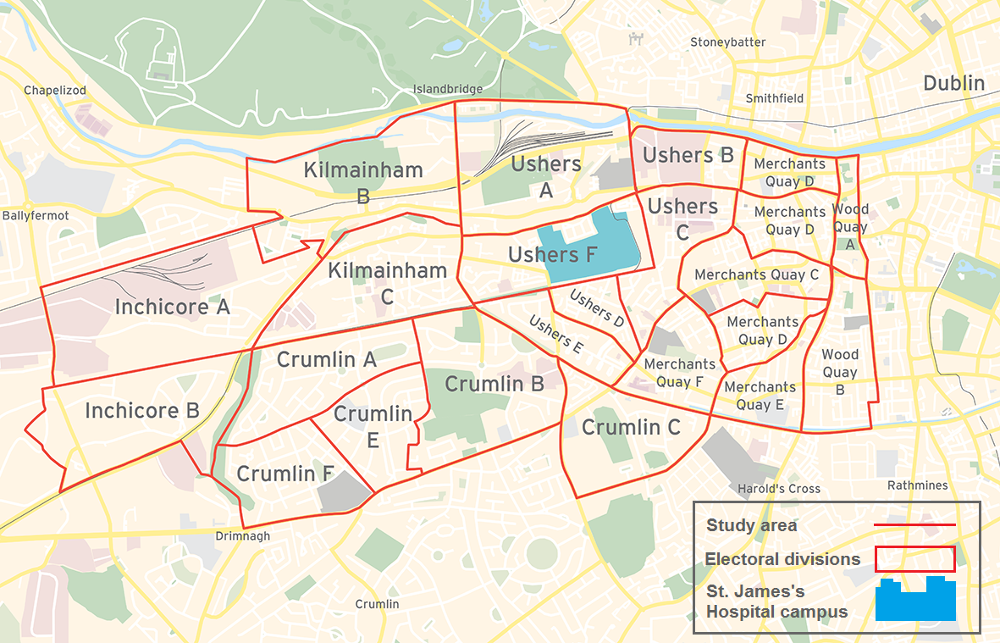

## **Eligibility**

The Community Grants Scheme will provide financial assistance to community-based clubs/groups, voluntary and not for profit organisations, for the development of projects in the locality (as defined above under Community Benefit Area).

In general, applications will be considered from not-for-profit organisations or associations which:

* Are registered and in good standing with their national representative, bodies (if relevant)
* Have a constitution or rules acceptable to the CBF Committee
* Hold annual general meetings.
* Have audited financial and other records available to the CBF Committee, if required
* May not be part of a formal structure as described above but who can demonstrate that they are representative of their local community.
* The fund **will not** cover promotion of religious or political causes.

**Application Assessment**

An assessment panel will be established comprising of a representative of BAM’s Community Benefit Fund Committee and an independent assessor experienced in philanthropy and/or grant evaluation in the context of community development and the not-for-profit sector. They will assess each application with an agreed marking methodology that is fair and transparent and make recommendations for final approval to BAM’s Community Benefit Fund Committee. In deciding the final allocations of funding to projects, the Committee may take account of a number of factors including geographical balance and the desirability to fund a variety of different types of work and the relative disadvantage of the area where the organisation is located or will serves. (This may include cross-referencing the location of the facility (or the area it serves) with the Pobal Hasse deprivation index which is available on [www.pobal.ie](http://www.pobal.ie).)

**Key Evaluation Criteria**

* **Impact and reach**
* **Need**
* **Innovation**
* **Additionality**
* **Cross community and partnership strategies**

So, when making an application, organisations should ensure they **demonstrate in the application** relevant issues such as**:**

* The impact of the proposal in terms of numbers reached.
* The improvements the project will make to the local socio-economic, physical or cultural environment or the health and wellbeing of the community, outlining what difference in outcomes the project will make for the beneficiaries or community.
* The demonstrable need - is there a gap in existing provision or services.
* The sustainability of the initiative - given the limited scope of the grant, how is it envisaged that the project or activity can maintain itself in the future?
* The scope for additionality i.e., will this grant impact on the organisation’s ability to draw down further funding?

And where relevant:

* How is the proposed project or activity utilising innovative and/or creative methods to solve a community need? How will the grant allow for a new activity to be developed as opposed to the grant funding core activities?
* How does the organisation work across the community, or in collaboration with other local organisations? How does it make its work accessible to a wide number of people and/or diverse communities?

The total amount available for 2024 is €50,000. Applicants should be aware that the grant scheme may be oversubscribed. Therefore, in such circumstances, all applications fulfilling the conditions may not be successful or may be for a lesser amount.

N.B. The Community Benefit Fund Committee reserve all rights to modify at any time and/or to terminate this grant scheme and/or to make whatever decisions in regard to the operation of this grants scheme that may be required and their determination(s) on all these matters shall be final and there shall be no right of appeal.

Code of Governance for Community and Voluntary organisations

The Community Benefit Programme for the new children’s hospital and BAM’s Community Benefit Fund Committee would encourage all funded bodies to adopt the Governance Code, a Code of Practice for Good Governance of Community, Voluntary and Charitable Organisations, which will assist in achieving excellence in all areas of your work. The Governance Code asks organisations to agree to operate to key principles in order to run their organisation more effectively in areas such as leadership, transparency and accountability and behaving with integrity. Further information on the Code is available at [www.governancecode.ie](http://www.governancecode.ie) We would in particular request that all organisations have a Child Safety policy in place.

**TERMS AND CONDITIONS**

* The Community Grants Scheme will support community activities promoted by community and voluntary groups subject to available resources.
* Activity must benefit the local community and relate to at least one key priority.
* The Community Benefit Fund Committee, with the assistance of an Independent Assessor will assess applications taking into consideration it’s available financial resources and reserves the right to award grants on this basis.
* The information supplied by the applicant group /organisation must be accurate and complete.
* Misinformation may lead to disqualification and/or the repayment of any grant made.
* All information provided in respect of the application for a grant will be held electronically and may be made available to third parties involved in the management and administration of this grants scheme.
* The Community Benefit Fund Committee reserve the right to publish a list of all grants awarded including the name of the group/organisation receiving funding, the general location of the group and the general purpose of the grant.
* Information provided in respect of the application for a grant will only be used for the purpose of administering the Community Grants Scheme 2024.
* The Community Benefit Fund Committee in evaluating applications under the Community Grants Scheme may seek advice and consult with other agencies and may disclose information on projects under consideration to those experts and agencies.
* It is the responsibility of each organisation to ensure that it has proper procedures and policies in place including appropriate insurance to support the proposed activity.
* Where relevant, applicants must provide evidence of a Child Safeguarding Statement and meet all the requirements of the Children First Act 2015 which includes Garda vetting for all officers and those associated with the project.
* Applications will be accepted by email and should be sent to **CommunityGrants@nph.ie**
* Applications by post should use the correct value of postage stamps and allow sufficient time to ensure delivery not later than the closing date of **19th April 2024**
* Only completed, signed applications submitted by **5.30 pm on 19th April 2024** on the official Community Grants Scheme 2024 application form will be considered.
* Successful applicants must submit a progress report on the project funded if requested by the Community Benefit Fund Committee.
* Evidence of expenditure, receipts /invoices must be retained and provided to the Community Benefit Fund Committee if requested.
* BAMs contribution and the Community Benefit Programme for the new children’s hospital must be publicly acknowledged in all materials associated with the purpose of the grant.
* Generally, no third party or intermediary applications will be considered.
* Late applications will not be considered.
* Applications will be accepted by email and should be sent to **CommunityGrants@nph.ie**
* Claims that any application form has been lost or delayed in the post will not be considered, unless applicants have a Post Office Certificate of Posting in support of such claims.
* Breaches of the terms and conditions of the grants scheme may result in sanctions including disbarment from future grant applications.
* Some grants awarded may be conditional on a further agreement between the Community Benefit Fund Committee and the proposed grantee on the application of the grant.
* Applicants are required to have a bank account in the official name of the organisation/group as no payments can be made to Third party or personal accounts. Bank, Post Office or Credit Union accounts are acceptable.

**Freedom of Information and General Data Protection Regulations**

* The Freedom of Information Act 2014 applies to all the records held by the National Paediatric Hospital Development Board (NPHDB) which in involved in the oversight of this grants scheme. Under the Freedom of Information Act 2014, details contained in applications and supporting documents may, on request, be released to third parties. If there is information contained in your application which is sensitive or confidential in nature, please identify it and provide an explanation as to why it should not be disclosed. If a request to release sensitive information under the legislation is received, you will be consulted before a decision on whether or not to release the information is made. In the absence of the identification of particular information as sensitive, it could be disclosed without any consultation with you.
* General Data Protection Regulation. The purpose for processing your data is to process your application for the BAM Community Grant Scheme 2024. The information you provide will be assessed by the Community Benefit Fund Committee with the assistance of an Independent Assessor who will check applications meet the grant scheme criteria, terms and conditions and governance requirements. Your information will be retained for five years. If you do not furnish the personal data requested, we will not be able to process your application. You have the following rights, in certain circumstances and subject to applicable exemptions, in relation to your personal data:
* the right to access the personal data that we hold about you, together with other information about our processing of that personal data.
* the right to require us to rectify any inaccuracies in your personal data.
* the right to require us to erase your personal data.
* the right to request that we no longer process your personal data for particular purposes.
* the right to object to our use of your personal data or the way in which we process it.

Please note that to help protect your privacy we take steps to verify your identity before granting access to personal data. If you would like to exercise any of these rights, please submit a request to our Data Protection Officer outlining the specific details of the request: Email: [dataprotection@nph.ie](mailto:dataprotection@nph.ie) . All valid requests will be processed without undue delay and in any event within one month of receipt of the request. This period may be extended by up to two further months where necessary.